1 May 2024

Dear Editor,

We hope that you will consider our manuscript entitled “Birds of a feather flock together: Light pollution’s effects differ by social context” for publication in *Biology Letters*.

We believe that the data presented in this manuscript are of great interest to the broad readership of *Biology Letters*. In our manuscript, we analyze behavior, physiology, and gene expression to characterize the response to light pollution in isolation or socially housed birds. We found that social conditions amplify the negative responses to light at night on a behavioral and molecular level. This is the first research of our knowledge to show social circadian regulation on a molecular level in vertebrates. We consider these findings important for improving our understanding of light pollution on social species as well as the broader impacts of social interactions on circadian biology.

No part of this manuscript has been reported previously and it is not under consideration elsewhere. All the data were collected under the appropriate state and federal laws and approved by the authorities of the University of Nevada, Reno. All authors of this paper have made significant contributions throughout the project and have carefully commented on all manuscript drafts. All authors have agreed to this submission.

Thank you for considering this manuscript for publication in *Biology Letters*, and we look forward to hearing from you.

Sincerely on behalf of the coauthors,

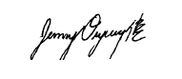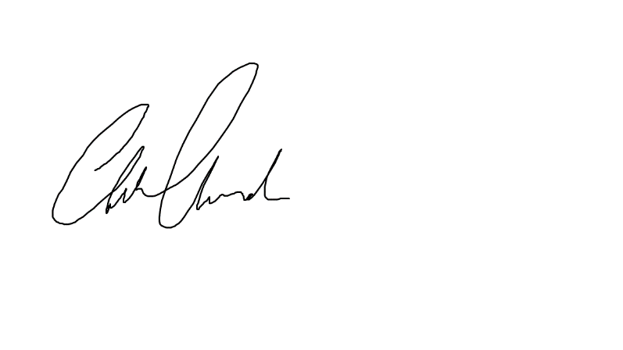

Cassandra Hui Jenny Ouyang, PhD

PhD Candidate Assistant Professor

Department of Biology Department of Biology

University of Nevada, Reno University of Nevada, Reno